Review Article

Phytogenics in Aquaculture: A Short Review of Their Effects on Gut Health and Microflora in Fish
Christopher Marlowe A. Caipang*,
College of Liberal Arts, Sciences, and Education and the Center for Chemical Biology and Biotechnology, University of San Agustin, Iloilo City 5000, Philippines

*Corresponding Author
Email:
Contact number:
ORCID identifier (At least the corresponding author must have an ORCID identifier. If you haven’t registered yet, please do so through this link https://orcid.org/register):
Phytogenics in Aquaculture: A Short Review of Their Effects on Gut Health and Microflora in Fish
Abstract
Increasing pace in aquaculture development to meet the growing food requirements of the population has greatly compromised the carrying capacity of the culture environment and has placed the aquacultured animals at heightened risk of getting diseases due to pathogens. At present, chemotherapy is widely used as means to prevent or treat infectious diseases in aquaculture; however, the use of these drugs poses multiple negative impacts on fish and human health, as well as the environment. Recently, research initiatives are focused on the use of plant products and their derivatives as a means of controlling diseases in aquaculture. They are regarded as a promising alternative to the use of chemical treatments for infectious diseases in fish. Plant-derived products or phytogenics have been shown to stimulate appetite and promote weight gain in farmed animals, act as immunostimulants, and possess potent anti-pathogenic properties in fish. Their potency is mediated by the presence of bioactive molecules including alkaloids, terpenoids, saponins, and flavonoids, among others. Moreover, nutritional strategies are geared towards the use of these phytogenics in modulating immune and physiological responses, as well as promoting optimum health and microbial community in the gastrointestinal tract of fish. This review synthesizes the current knowledge on the use of phytogenic feed additives in aquaculture by focusing on how these substances act as modulators of health and bacterial community in the gut of fish.

Keywords: aquaculture, immune response, microbiome, mucosal immunity, phytobiotics
1. Introduction
There is a growing interest in developing various feed formulations and feeding strategies that can stimulate the development and health status of the gut in fish as well to modulate the microbial community in the gastro-intestinal tract. These strategies are aimed towards improvement in aquaculture productivity. As intensification proceeds, various diseases and health issues are critical in an aquaculture facility. It is widely known that disease outbreaks in an aquaculture site are due to several factors, which are related to the husbandry and the prevailing environmental conditions. As a result, aquacultured fish are becoming more susceptible to both pathogenic and opportunistic bacteria.
The use of antibiotics and chemotherapeutants for the treatment and prophylaxis in intensive aquaculture is losing its popularity because of their negative impacts to the host and to their immediate environment. As a result, several studies on the interactions between growth and immunity in fish, as well as the development of environment-friendly alternatives to antibiotics that would keep the fish healthy, are being conducted. More specifically, studies on the development of probiotics and natural immunostimulants have increased, as well as improvements on technological knowledge for the treatment of both infectious and non-infectious diseases are gaining much attention and support as tools for fish health management (Bondad-Reantaso et al. 2005). With restrictions on the use or total ban of using dietary antibiotics, there should be a need to explore novel ways of improving and protecting the health status of farmed animals, enhancing their growth performance, and increasing bioavailability of nutrients. This can be attained by provision of optimum conditions when rearing the animals, as well as combining the best pronutrients that are supplemented in the feeds of the animals (Rosen 1996). In addition, the demand for the global production of food that is safe to consumers and does not have issues on public health has triggered the search for alternative natural growth promoters or additives that can be incorporated in the manufacture of feeds for aquatic animals. Increased research undertakings towards the development of novel dietary supplements and new feeding strategies are now being implemented that can promote optimum health and good growth in fish. A diverse array of feed enzymes, probiotics, prebiotics, organic acids, and phytogenics are used as feed additives for aquaculture and their effects have been assessed in some laboratory studies (Sethiya 2016). Among these feed supplements, various phytogenics that are used as additives for the animal feed industry have gained considerable attention in recent years (Windisch et al. 2008; Upadhaya and Kim 2017). Unlike synthetic antibiotics, these additives are free from residues and are generally considered as safe to be incorporated as ingredients in the food industry, as well as in animal diets (Hashemi et al. 2008; Li et al. 2016).
This review presents and evaluates existing knowledge on the use of phytogenics and their biological actions in relation to mucosal health in fish that are being utilized in aquaculture. While most of the previous studies on plant-based materials concentrated on developing alternative feed ingredients and their effects on growth and immunity in fish, this present review focused on the beneficial effects of these phytogenics as feed additives on gut health and the microbial community in the gastrointestinal tract of the fish, the two areas that are relatively new in the study of fish nutritional immunology. Future perspectives on the expansion of this commodity as a feed additive in aquaculture are also discussed in this paper.
2. Classification of phytogenics
Plants contain a diverse range of low-molecular weight secondary metabolites, and these compounds serve several functions: they enable the plants to interact with the environment and to act as a defense against physiological and environmental stressors, predators, and pathogens (Sethiya 2016). While some of these metabolites possess toxic substances, most of these secondary metabolites have been reported to demonstrate beneficial effects in animal metabolism when used as feed additives. In recent years, the feed industry for both terrestrial and aquatic animals has been aware that various plant extracts are able to play significant roles in the nutrition and health of the animals (Sethiya 2016). As a result, there are many plants that have been tested and were found to exhibit beneficial effects on farmed animals when used as feed additives (Huyghebaert et al. 2011). In addition, most of these plant-derived substances are regarded as safe for animals, the consumers, and the environment (Liu et al. 2011; Pavela 2015).
Phytogenics are plant-derived, natural compounds that are incorporated in the diets, which can enhance animal productivity. Plant-derived products have been reported to possess beneficial properties including: anti-stress, appetite stimulation, growth promotion, immunostimulation, and anti-pathogenic properties in fish and shrimp aquaculture due to the presence of several bioactive substances such as alkaloids, flavonoids, glycosides, phenolics, saponins, tannins, terpenoids, steroids, and essential oils (Citarasu 2010; Chakraborty and Hancz 2011; Reverter et al. 2014; Hashimoto et al. 2016). Moreover, their use are believed to reduce the costs in the treatment of diseases and are perceived to be more environment-friendly than synthetic substances because they are biodegradable and are less likely to produce drug resistance in pathogens due to the high diversity of these plant extracts (Blumenthal et al. 2000; Logambal et al. 2000; Olusola et al. 2013). Because of the many benefits of these plant-derived products, they have been used in food preservation, pharmaceuticals, alternative medicine, and natural therapies for many years (Jones 1996; Lis-Balchin and Deans 1997). Various herbs possess potent antimicrobial and antiviral properties (Smith-Palmer et al. 1998; Hammer et al. 1999) and are reported to stimulate the immune system (Chang et al. 1995; Barak et al. 2001). These plant products can be categorized on the basis of their physical characteristics and appearance. For example, essential oils, crude or processed parts of the plant as well as mixtures of plant powders or extracts are used in preventing and treating various infectious diseases of both terrestrial and aquatic animals (Sethiya et al. 2013; Dhama et al. 2015). In addition, they can also be classified on the basis of their growth habits (Asimi and Sahu 2013), and can be categorized either as a tree, shrub or a herb. The differences among them are the following: a tree stands on the stem; a shrub has multiple stems that form a bush. On the other hand, a herb does not have a firm stem but a flexible fleshy structure, which does not have the woody hard part as what is found in a tree or a shrub. In the last few years, the feed industry has recognized the vast potential of these plant-derived substances either as feed ingredients or feed additives for farmed animals. As a result, the following phytogenic substances are commonly utilized as feed additives: herbs, spices, essential oils, and non-volatile extracts (Steiner and Syed 2015). Botanicals or herbal extracts as well as essential oils (EO) are within the scope of European legislation; thus, they are categorized as ‘sensory additives’ (Steiner and Syed 2015). On the other hand, unprocessed herbs are still considered as feed materials; hence, they do not need any authorization prior to be used in the preparation of feeds (Huyghebaert et al. 2011).
Some of the commonly used plants as sources of phytogenics and are used as feed additives for the production of livestock and fish are listed in Table 1. The inclusion of these plants and their effects in the gut and in the digestive process are highlighted.
3. Effects on fish gut health
The term ‘gut health’ is currently gaining much attention in the animal production industry and this encompasses all the mechanisms and processes that take place in the gut (Cummings et al. 2004; Laudadio et al. 2012). The term is usually confined to the gastro-intestinal (GI) tract of the host and does not involve other organs (Bischoff 2011). The gut is the primary site for a number of important functions including, digestion, fermentation, nutrient absorption and metabolism, intestinal integrity, and immune regulation (Sommer and Backhed 2013). It is mainly composed of physical, chemical, immunological, and microbiological components, thereby acting as a selective barrier between the host and its immediate environment (Yegani and Korver 2008). It is reported that when the gut is exposed to harmful and infectious agents or pathogens, this causes an imbalance in the host that will result in sudden changes in the feeding activity, intestinal disorders, and suppression of the immune responses that can lead to a decrease in animal productivity (McDevitt et al. 2006).
There have been increasing scientific evidence that enable us to understand the effects of phytogenics based on studies that were conducted in monogastric animals (Steiner and Syed 2015). The possible effects of these plant-based additives to gut health and microbial community of the host are summarized in Figure 1 and may also be observed in aquatic animals. Humphrey and Klasing (2003) stressed that the effects of phytogenics on gut health can be any of the following: (a) antimicrobial action, (b) reduction of the incidence and severity of infections, (c) reduction on the microbial use of nutrients, (d) improvement in absorption of nutrients, (e) reduction in the production of growth-depressing metabolites, (f) modulation of gut microbiota, and (g) inhibition in the production of pro-inflammatory cytokines by immune cells in the gut. An increase in the digestibility is considered to be the major effect of phytogenics in farmed animals, as these substances aided in the improvement of feed conversion. The different biological parameters that are affected by these phytogenic feed additives include: increased secretions of digestive enzymes, modulation of the immune responses, changes in the villi morphology, and enhanced utilization of nutrients (Steiner and Syed 2015). All these parameters eventually result in a better growth performance of the animals. The above-mentioned biological parameters are not to be treated independently, rather they must be seen as interrelated with one another. Steiner and Syed (2015) postulated that the positive effects of these phytogenics on the morphology of the tissues and villi of the small intestines favored in the increased digestibility of nutrients. Furthermore, a more stable intestinal microbiota could be responsible in the reduction of microbial metabolite levels in the digestive tract; thus, putting less metabolic burden to the immune system and increasing available energy for growth.
It has been reported that herbs, spices, and their extracts can stimulate appetite and digestive enzymes in monogastric animals (Wenk 2003; Liu et al. 2011). The stimulation of digestive secretions and mucus, as well as the enhancement of digestive enzyme activities, are believed to be the major modes of nutritional action of these phytogenics in monogastric animals (Platel and Srinivasan 2004). For example, essential oils that were used as feed additives resulted in the increased activities of trypsin and amylase in broilers (Lee et al. 2003; Jang et al. 2004). Similarly, higher amylase, lipase, trypsin, and chymotrypsin activities were observed in weaned piglets fed herbal additives (Zhu et al. 2002). Herbal feed additives were also reported to stimulate the secretion of intestinal mucus in broilers that resulted in the lower adhesion rates of pathogens (Jamroz et al. 2006).
The beneficial effects of these plant-based additives were also observed in aquatic animals (Citarasu 2010; Asimi and Sahu 2013). Because of their beneficial effects, several of these plants have been used as phytogenics as feed additives to improve gut health as well as to enhance digestion in fish in order to improve growth performance. The active ingredients of these herb and spices in the diets are able to induce the secretion of the digestive enzymes that will stimulate the appetite; thus, increasing food consumption and conversion efﬁciencies. For example, Nile tilapia (Oreochromis niloticus) that were fed diets supplemented with a mixture of digestive herbal extracts and natural emulsifying agents had better feed conversion and protein efficiency than fish fed control diets that did not contain the mixtures (Ceulemans et al. 2009). Hot spices from peppers (e.g. capsaicin and piperine) and other essential oils containing cinnamaldehyde stimulated amylase production (Steiner and Syed 2015). Increased enzyme production can result in improvements in digestibility and availability of nutrients from these feedstuffs (Chesson 1987). Moreover, a reduction in the amount of undigested materials that pass into the large intestines will consequently decrease the amount of substrate that will be utilized by pathogenic bacteria for proliferation. Another phytogenics, Livol (IHF-1000), which is a herbal growth promoter that contains plant ingredients such as Bohaevia diffusa, Solanum nigrum, Terminaelia arjuna, Colosynth, and black salt has been demonstrated to signiﬁcantly improve digestion that led to better growth, production, and health in a number of cultivable ﬁshes (Shadakshari 1993; De Bolle et al. 1996; Jayaprakas and Euphrasia 1996). Maheshappa (1993) also studied the effects of Livol (IHF-1000) on rohu, Labeo rohita. Fish fed Livol-incorporated diet had enhanced digestive enzyme activity, which led to increased feed consumption. Aside from fish, phytogenics had beneficial effects on crustaceans. Papaya leaf meal increased protein digestion, food conversion ratio, and growth when fed to Penaeus monodon postlarvae (Peñaflorida 1995). In addition, P. monodon post-larvae fed with Artemia that has been enriched with ginger, Zingiber ofﬁcinalis, showed significant production of digestive enzymes (amylase, protease, and lipase), as well as better feed conversion efficiency (Venketramalingam et al. 2007). Aside from the antibacterial properties of onion and walnut leaf residues, Bello et al. (2012) observed an increase in the body weight of fish when their diets were supplemented with these plant additives. It was suggested that the increased digestive activity enhanced the production of vitamins, co-factors, and enzymes that resulted in good growth performance. Furthermore, an investigation of the intestinal villi of the fed fish showed increased villi height and width as well as cryptal depth that could be responsible in greater capacity for the absorption of nutrients (Bello et al. 2012). It cannot be ruled out that both onions and walnut leaves are rich in growth stimulants such as flavonoids, thiosulfinates, alkaloids, and tannins (Azu and Onyeagba 2007; Bello et al. 2013). Table 2a shows a summary of the effects conferred by these various phytogenics in fish gut health.
4. Effects on fish gut microflora
The gastro-intestinal tract of the fish is colonized by bacteria immediately after hatching, and the microbial community is influenced by both the surrounding environment and some endogenous factors (Balcázar et al. 2006; Sutili et al. 2018). In the early stages of fish development, the microbial community in the gut is very dynamic and this usually coincides when the immune system is starting to develop (Rombout et al. 2011). The presence of different bacterial profiles in the gastrointestinal tract of the fish is due to the emergence of a complex and dynamic community of intestinal microbiota, which is influenced by the diversity in the dietary habits and the environment of the fish (Austin 2006; Wong and Rawls 2012). This bacterial community and the metabolites that they produce have significant impacts on the health status of the host by modulating the immune system and other aspects of metabolism (Bento et al. 2013; Lazado and Caipang 2014).
The gut microbiota of fish is influenced by genetic, nutritional, microbiological, and environmental factors (Gómez and Balcázar 2008), and an imbalance in the gut microbiota of the host as a result of changes in the diet or the environment is detrimental for the growth performance and health of the animal (Steiner and Syed 2015). On the other hand, an ideal and stable gut microbiota favors optimum growth performance (Schaedler 1973). One of the factors that can influence gut microbiota is the diet of the host. The diet may alter microbial diversity in the gastrointestinal tract, which may have a crucial effect in the metabolism of the host (Ley et al. 2008). Plant-based feed additives have the ability to exert a prebiotic-like effect on the gastro-intestinal tract as well as to modulate the gut bacterial community (Laparra and Sanz 2010).
There are limited studies that demonstrate the effects of phytogenics as feed additives on the gut microbiota in fish because earlier studies have focused on the effects of these various plant materials as feed ingredients rather than as feed additives on the microbial communities of the fish gut (Ringø et al. 2008; Silva et al. 2011; Reveco et al. 2014; Zarkasi et al. 2017). Some of these plant ingredients contain anti-nutritional factors that hinder protein digestion in the host even if they have high carbohydrate and protein levels. For example, it was demonstrated that the inclusion of soybean meal in the diet of the fish contributed to the increased abundance of the microbial community and its diversity in the gut (Ringø et al. 2008). However, when used as a feed additive it is unclear whether these plant-based substances will exert a similar effect on gut microbiota. In spite of the scarcity of research studies along this line, there were some initiatives on testing the beneficial effects of using various herbs as feed additives for fish. Liu et al. (2004) added various Chinese herbs to carp diets and observed the presence of higher populations of useful bacteria such as Bacillus spp., while reducing the populations of Aeromonas, Plesiomonas, Pseudomonas, Vibrio, and Enterobacter. In a study by Giannenas et al. (2012) on the effects of supplementation with phytogenics, thymol, and carvacrol on the intestinal microbiota and anti-oxidant status of rainbow trout, Oncorhynchus mykiss showed that Lactobacillus loads were higher in carvacrol-fed group compared with the control. Moreover, both phytogenics significantly improved antioxidant status in the fish. The authors concluded that additional work is needed using molecular tools in order to identify with increased precision the bacterial species that are mostly affected by these phytogenics and how those changes in the bacterial profile will impact the health status of the fish or how will the fish resist various pathogens. Similarly, Ran et al. (2016) tested the effects of a commercial mixture of thymol and carvacrol as feed additives for hybrid tilapia (O. niloticus x O. aureus). After 6 weeks of feeding, there was a significant change in the gut microbiota of the fish. Using denaturing gradient gel electrophoresis (DGGE) analysis, Sutili et al. (2016) evaluated the effects of essential oils from American basil, Ocimum americanum on the intestinal microbiome in red drum, Sciaenops ocellatus, following oral administration together with the feeds. Navarrete et al. (2010) also evaluated the effects of a diet supplemented with essential oils derived from Thymus vulgaris on the bacterial composition of the gut in rainbow trout, Oncorhynchus mykiss, using temperature gradient gel electrophoresis analysis (TGGE). In both studies, the phytogenics did not affect the population of the gut microbiota in the host. A summary of the effects on fish gut microflora following dietary inclusion of these phytogenics is shown in Table 2b.
In these previous studies, the mechanisms and interactions of these phytogenic feed additives in the gastrointestinal tract of the fish have not been clearly elucidated. For example, there are bioactive molecules and extracts from plants that are sensitive to acidic environment and digestive enzymes during passage along the gastrointestinal tract (Zhang et al. 2016). This was not demonstrated whether there was degradation and/or absorption of these phytogenic feed additives along the different regions of the digestive tract. It was not also shown at which sites of the gut are these phytogenic additives are absorbed considering that phytogenics are so diverse and each phytogenic molecule could be targeted by certain regions of the gut. The phytogenic compounds could be broken down and absorbed in the upper region of the digestive tract before reaching their optimum site of action; hence, it is necessary that these compounds are protected from gastric absorption (Kohlert et al. 2000; Michiels et al. 2008; Zhang et al. 2016). The use of phytogenics as feed additives will likely have a negligible effect on the bacterial composition in the gut of the fish if sub-optimal doses of the phytogenics are incorporated in the diets. It is also postulated that such conditions would take place in relation to the stability and interaction of the phytogenics with environmental factors, type of food, and the host (Sutili et al. 2018).
5. Future perspectives
It is evident that phytogenics and their active components are able to affect the gut health as well as to modulate the intestinal microbiota of the fish; thus, they are good candidates to be used as health-promoting agents in aquaculture. Most of the published studies demonstrated that phytogenics can change the microbiome of the gut of the fish, but the benefits to growth and/or systemic immunity were not clearly established. Based on
available literature, an illustration of the effects on gut health and microflora in fish following dietary inclusion of various phytogenics is shown in Figure 2. The in vivo effects of dietary inclusions with these phytogenics in fish remain controversial (Sutili et al. 2018) largely because their modes of actions are largely dependent on these factors including, the methods of extraction, the concentration of the additives, manner of delivery and storage conditions before feeding. The beneficial properties and efficiency of these phytogenic feed additives in impacting the health of the fish are largely dependent on the part of the plant that was used as raw material, the method of extraction, and the concentration of the extract (Reverter et al. 2014). Although there were some studies that provided details on the multiple modes of action and potential application of phytogenics in aquaculture, there have been very few initiatives to standardize the extraction procedures, the dosages to be incorporated in the feeds, and the mode of application for each phytogenic substance. Delivery of the phytogenics in fish as well as in crustaceans via injection might be the most rapid way of administration; however, this technique is laborious and stressful for the host animal, especially for juveniles. Hence, oral administration seems to be the most viable and suitable method of application (Yoshida et al. 1995). In addition, the effects of these phytogenic feed additives on fish and crustaceans are observed in a dose-dependent manner, and most often there is a tendency to use these substances in high doses. As such, it is important that the effective concentration of the phytogenics to be incorporated in the feeds has to be determined accurately (Kajita et al. 1990; Harikrishnan et al. 2011). Initiatives on quantifying and characterizing the chemical components of these phytogenics should be carried out in order to identify the bioactive substances that are responsible for the direct beneficial effect, and thus will ensure the formulation of standard protocols on the procedures of extraction, the optimum dose to be used, and how the substance will be delivered to the fish and crustaceans (Reverter et al. 2014). Further studies need to be undertaken in order to gain a deeper understanding on the manner by which these phytogenics act on to both pathogenic microorganisms and the normal microflora of the gut in order to grasp a clearer knowledge on their impacts on the host and to the environment as well. Moreover, phytogenics may exhibit greater effects to the host because of their wide chemical diversity, and they could elicit a greater range of interactions among the individual components due to the presence of multiple potential action sites. It is also worthwhile to consider that the feed ingredients and the manufacturing process may interfere with the stability of these phytogenic feed additives during the feed manufacturing process. This in turn could have profound effects on the immune responses in the gut and also on the dynamics of the microbial community in the gut of the fish.
Lastly, it should be emphasized that the gastrointestinal system in vertebrates is a well-organized and very complicated micro-ecosystem in itself (Yang et al. 2015), and is predominantly composed of epithelial cells, the mucosal immune system, and its associated microbial community, which could either be composed of pathogenic or non-pathogenic bacteria. Any change that disrupts this balance would likely result in the alteration of gut functions, which can affect gut health and may undermine thel growth and well-being of the cultured animals. As described in the preceding section, phytogenic feed additives possess multiple functions that include antimicrobial and antioxidant activities as well as digestion- and immune-enhancing properties. It is crucial to know the specific effect and the potential target site of each phytogenic compound and to determine whether such effects will be directed towards the gut of the host or to its gut microbiota. This information is vital as this will facilitate the manner by which these phytogenic compounds are incorporated in the feed.
In conclusion, phytogenic feed additives are composed of a wide array of active ingredients and they constitute as one of the most promising alternatives to antibiotics in aquaculture. However, their utilization in aquaculture has been limited due to their inconsistencies on the effects on the growth and systemic immunity of the host, as well as the lack of a thorough understanding on their modes of action especially in gut health and gut microbiota. A clearer understanding on the effects of these phytogenic feed additives to aquatic organisms should focus on these important aspects: gut physiology and immunology, gut bacterial community, and the interplay between the gut and the microbiota. Elucidation on how these factors affect one another will facilitate the optimum use of these phytogenic feed additives in achieving an economically sound and sustainable production in aquaculture. Finally, even though phytogenic feed additives are generally regarded as safe, the potential risks on their application to the cultured fish and to public health need to be carefully evaluated and monitored in the interest of food safety issues.

Acknowledgments
Author Contributions (Just insert here the CRediT author statement you provided in the cover letter)
Conflicts of Interest (Even if there is no conflict of interest, you still need to explicitly mention it here.)
References

Asimi OA, Sahu NP. 2013. Herbs/spices as feed additive in aquaculture. Scient J Pure Appl Sci. 2(8): 284-292. Available from: https://doi.org/ 10.14196/sjpas.v2i8.868
Austin B. 2006. The bacterial microflora of fish, revised. Scient World J. 6: 931–945. Available from: https://doi.org/10.1100/tsw.2006.181.
Azu NC, Onyeagba RA. 2007. Antimicrobial properties of extracts of Allium cepa (onions) and Zingiber officinale (ginger) on Escherichia coli, Salmonella typhii and Bacillus subtilis. The Internet J Trop Med. 3(2): 1-8. Available from: https://ispub.com/IJTM/3/2/11056
Balcázar JL, de Blas I, Ruiz-Zarzuela I, Cunningham D, Vendrell D, Muzquiz JL. 2006. The role of probiotics in aquaculture. Vet Microbiol. 114(3-4): 173–186. Available from: https://doi.org/10.1016/j.vetmic.2006.01.009
Barak V, Halperin T, Kalickman I. 2001. The effect of Sambucol, a black elderberry-based, natural product, on the production of human cytokines: 1. inflammatory cytokines. Eur Cytokine Netw. 12: 290–296.
Bello OS, Emikpe BO, Olaifa FE. 2012. The Body Weight Changes and Gut Morphometry of Clarias gariepinus juveniles on Feeds Supplemented with Walnut (Tetracarpium conophorum) Leaf and Onion (Allium cepa) Bulb Residues. Int J Morphology. 30(1): 253-257. Available from: http://dx.doi.org/10.4067/S0717-95022012000100045
Bello OS, Olaifa FE, Emikpe BO, Ogunbanwo ST. 2013. Potentials of walnut (Tetracarpium conophorum Mull Arg.) leaf and onion (Allium cepa Linn) bulb extracts as antimicrobial agents for fish. African J Mirobiol Res. 7(19): 2027-2033. Available from: https://doi.org/10.5897/AJMR12.814
Bento MHL, Ouwehand AC, Tiihonen K, Lahtinen S, Nurminen P, Saarinen MT, et al. 2013. Essential oils and their use in animal feeds for monogastric animals – effects on feed quality, gut microbiota, growth performance and food safety: a review. Veterinarni Medicina. 58(9): 449–458. Available from: https://doi.org/10.17221/7029-VETMED
Bischoff SC. 2011. Gut health: A new objective in medicine? BMC Medicine. 9:24. Available from: https://doi.org/10.1186/1741-7015-9-24
Blumenthal M, Godlberg A, Brinckann J. 2000. Herbal Medicine: Expanded Commission E Monographs. Americal Botanical Council: Integrative Medicine Communications, Newton, MA, USA. pp. 401-403.
Bondad-Reantaso MG, Subasinghe RP, Arthur JR, Ogawa K, Chinabut S, Adlard R, Tan Z, Shariff M. 2005. Disease and health management in Asian aquaculture. Vet Parasitol. 132(3-4): 249-272. Available from: https://doi.org/10.1016/j.vetpar.2005.07.005
Ceulemans S, Robles R, Coutteau P. 2009. Innovative Feed Additives Improve Feed Utilization In Nile Tilapia, Global Aquaculture Advocate. November/December 2009.
Chakraborty SB, Hancz C. 2011. Application of phytochemicals as immunostimulant, antipathogenic and antistress agents in finfish culture. Rev Aqua. 3(3): 103-119. Available from: https://doi.org/10.1111/j.1753-5131.2011.01048.x
Chang CP, Chang JY, Wang FY, Change JG. 1995. The effect of Chinese medicinal herb Zingiberis rhizoma extract on cytokine secretion by human peripheral blood mononuclear cells. J Ethnopharmacol. 48(1): 13–19. Available from: https://doi.org/10.1016/0378-8741(95)01275-I
Chesson A. 1987. Supplementary enzymes to improve the utilization of pig and poultry diets. In Recent Advances in Animal Nutrition; Haresign W, Cole DJA, editors. Butterworths: London, U.K. Available from: https://doi.org/10.1016/B978-0-407-01163-2.50010-2
Citarasu T. 2010. Herbal biomedicines: a new opportunity for aquaculture industry. Aquacult Int. 18(3): 403–414. Available from: https://doi.org/10.1007/s10499-009-9253-7
Cummings JH, Antoine JM, Azpiroz F, Bourdet-Sicard R, Brandtzaeg P, et al. 2004. PASSCLAIM-gut health and immunity. Eur J Nutr. 43: 118-173. Available from: https://doi.org/10.1007/s00394-004-1205-4
De Bolle MF, Osborn RW, Goderis IJ, Noe L, Acland D, Hart CA, Torrekens S, Van Leuven F, Broekart NF. 1996. Antimicrobial peptides from Mirablis jalapa and Amaranthus caudalus: expression, processing, localization and biological activity in transgenic tobacco. Plant Mol Biol. 31(5): 993–1008. Available from: https://doi.org/10.1007/BF00040718
Dhama K, Latheef SK, Saminathan M, Samad HA, Karthik K, et al. 2015. Multiple Beneficial Applications and Modes of Action of Herbs in Poultry Health and Production-A review. Int J Pharmacol. 11(3): 152-176. Available from: https://doi.org/10.3923/ijp.2015.152.176
Giannenas I, Triantafillou E, Stavrakakis S, Margaroni M, Mavridis S, Steiner T, Karagouni E. 2012. Assessment of dietary supplementation with carvacrol or thymol containing feed additives on performance, intestinal microbiota and anti-oxidant status of rainbow trout (Oncorhynchus mykiss). Aquaculture. 350–353: 26–32. Available from: https://doi.org/10.1016/j.aquaculture.2012.04.027
Gómez GD, Balcázar JL. 2008. A review on the interactions between gut microbiota and innate immunity of fish. FEMS Immunol Med Microbiol. 52(2): 145–154. Available from: https://doi.org/10.1111/j.1574-695X.2007.00343.x
Hammer KA, Carson CF, Riley TV. 1999. Antimicrobial activity of essential oils and other plant extracts. J Appl Microbiol. 86: 985–990. Available from: https://doi.org/10.1046/j.1365-2672.1999.00780.x
Harikrishnan R, Balasundaram C, Heo MS. 2011. Diet enriched with mushroom Phellinus linteus extract enhances the growth, innate immune response, and disease resistance of kelp grouper, Epinephelus bruneus against vibriosis. Fish Shellfish Immunol. 30(1): 128–134. Available from: https://doi.org/10.1016/j.fsi.2010.09.013
Hashemi SR, Zulkifli I, Zunita Z, Somchit MN. 2008. The effect of selected sterilization methods on antibacterial activity of aqueous extract of herbal plants. J Biol Sci 8(6): 1072–1076. Available from: https://doi.org/10.3923/jbs.2008.1072.1076
Hashimoto GSO, Marinho Neto F, Ruiz ML, Acchile M, Chagas EC, Chaves FCM, et al. 2016. Essential oils of Lippia sidoides and Mentha piperita against monogenean parasites and their influence on the hematology of Nile tilapia. Aquaculture. 450: 182–186. Available from: https://doi.org/10.1016/j.aquaculture.2015.07.029
Humphrey BD, Klasing KC. 2003. Modulation of nutrient metabolism and homeostasis by the immune system. Proceedings of the European Symposium on Poultry Nutrition, August 10-14, 2003, Lillehammer, Norway.
Huyghebaert G, Ducatelle R, Van Immerseel F. 2011. An update on alternatives to antimicrobial growth promoters for broilers. Vet J. 187(2): 182–188. Available from: https://doi.org/10.1016/j.tvjl.2010.03.003
Jamroz D, Wertelecki T, Houszka M, Kamel C. 2006. Influence of diet type on the inclusion of plant origin active substances on morphological and histochemical characteristics of the stomach and jejunum walls in chicken. J Anim Physiol Anim Nutr. 90(5-6): 255–268. Available from: https://doi.org/10.1111/j.1439-0396.2005.00603.x
Jang IS, Ko YH, Yang HY, Ha JS, Kim JY, Kim JY, Kang SY, Yoo DH, Nam DS, Kim DH, Lee CY. 2004. Influence of essential oil components on growth performance and the functional activity of the pancreas and small intestine in broiler chickens. Asian–Australasian J Anim Sci. 17(3): 394–400. Available from: https://doi.org/10.5713/ajas.2004.394
Jayaprakas V, Euphrasia J. 1996. Growth performance of Labeo rohita (Ham.) to Livol (IHF-1000), a herbal product. Proc Indian Natl Sci Acad B. 63: 1–10.
Jones FA. 1996. Herb-useful plants. Their role in history and today. Eur J Gastroenterol Hepatol. 8: 1227–1231.
Kajita Y, Sakai M, Atsuta S, Kobayashi M. 1990. The immunomodulatory effects of levamisole on rainbow trout, Oncorhynchus mykiss. Fish Pathol. 25(2): 93–98. Available from: https://doi.org/10.3147/jsfp.25.93
Kohlert C, van Rensen I, Marz R, Schindler G, Graefe EU, Veit M. 2000. Bioavailability and pharmacokinetics of natural volatile terpenes in animals and humans. Planta Medica. 66(6): 495–505. Available from: https://doi.org/10.1055/s-2000-8616
Laparra JM, Sanz Y. 2010. Interactions of gut microbiota with functional food components and nutraceuticals. Pharmacol Res. 61(3): 219–225. Available from: https://doi.org/10.1016/j.phrs.2009.11.001
Laudadio V, Dambrosio A, Normanno G, Khan RU, Naz S, Rowghani E, Tufarelli V. 2012. Effect of Reducing Dietary Protein Level on Performance Responses and some Microbiological Aspects of Broiler Chickens under Summer Environmental Conditions. Avian Biol Res. 5(2): 88-92. Available from: https://doi.org/10.3184/175815512X13350180713553
Lazado CC, Caipang CMA. 2014. Mucosal immunity and probiotics in fish. Fish Shellfish Immunol. 39(1): 78–89. Available from: https://doi.org/10.1016/j.fsi.2014.04.015
Lee KW, Everts H, Kappert HJ, Frehner M, Losa R, Beynen AC. 2003. Effects of dietary essential oil components on growth performance, digestive enzymes and lipid metabolism in female broiler chickens. Brit Poult Sci. 44(3): 450–457. Available from: https://doi.org/10.1080/0007166031000085508
Ley RE, Lozupone CA, Hamady M, Knight R, Gordon JI. 2008. Worlds within worlds: evolution of the vertebrate gut microbiota. Nature Rev Microbiol. 6: 776–788. Available from: https://doi.org/10.1038/nrmicro1978
Li HN, Zhao PY, Yan L, Hossain MM, Kang J, Kim IH. 2016. Dietary Phytoncide Supplementation Improved Growth Performance and Meat Quality of Finishing Pigs. Asian Australas J Anim Sci. 29(9): 1314–1321. Available from: https://doi.org/10.5713/ajas.15.0309
Lis-Balchin M, Deans SG. 1997. Bioactivity of selected plant essential oils against Listeria monocytogenes. J Appl Bacteriol. 82(6): 759–762. Available from: https://doi.org/10.1046/j.1365-2672.1997.00153.x
Liu HB, Zhang Y, Yang YH, Lu TY, Ye JD. 2004. Effects of five Chinese herb medicines as additive in feed on the growth and intestinal microflora in common carp (Cyprinus carpio). J. Dalian Fisheries Univ 19: 16-20.
Liu H-W, Tong J-M, Zhou D-W. 2011. Utilization of Chinese Herbal Feed Additives in Animal Production. Agricult Sci China. 10(8): 1262-1272. Available from: https://doi.org/10.1016/S1671-2927(11)60118-1
Logambal SM, Venkatalakshmi S, Michael RD. 2000. Immunostimulatory effect of leaf extract of Ocimum sanctum Linn. in O. mossambicus (Peters). Hydrobiologia. 430: 113–120. Available from: https://doi.org/10.1023/A:1004029332114
Maheshappa K. 1993. Effect of different doses of livol on growth and body composition of rohu, Labeo rohita (Ham.) M.F.Sc Thesis, University of Agricultural Science, Bangalore, p 59.
McDevitt RM, Brooker JD, Acamovic T, Sparks NHC. 2006. Necrotic enteritis; a continuing challenge for the poultry industry. World's Poult Sci J. 62(2): 221-247. Available from: https://doi.org/10.1079/WPS200593
Michiels J, Missotten J, Dierick N, Fremaut D, Maene P, De Smet S. 2008. In vitro degradation and in vivo passage kinetics of carvacrol, thymol, eugenol and trans-cinnamaldehyde along the gastrointestinal tract of piglets. J Sci Food Agric. 88(13): 2371–2381. Available from: https://doi.org/10.1002/jsfa.3358
Navarrete P, Toledo I, Mardones P, Opazo R, Espejo R, Romero J. 2010. Effect of Thymus vulgaris essential oil on intestinal bacterial microbiota of rainbow trout, Oncorhynchus mykiss (Walbaum) and bacterial isolates. Aquac Res. 41(10): e667–e678. Available from: https://doi.org/10.1111/j.1365-2109.2010.02590.x
Olusola SE, Emikpe BO, Olaifa FE. 2013. The potentials of medicinal plant extracts as bio-antimicrobials in aquaculture. Int J Med Arom Plants 3: 404-412.
Pavela R. 2015. Essential oils for the development of eco-friendly mosquito larvicides: A review. Industrial Crops Prod. 76: 174–187. Available from: https://doi.org/10.1016/j.indcrop.2015.06.050
Peñaﬂorida VD. 1995. Effect of papaya leaf meal on the Penaeus monodon post larvae. Israeli J Aquac Bamidgeh. 47: 25–33.
Platel K, Srinivasan K. 2004. Digestive stimulant action of spices: a myth or reality? Indian J Med Res. 119(5): 167–179.
Ran C, Hu J, Liu W, Liu Z, He S, Dan BCT, et al. 2016. Thymol and Carvacrol Affect Hybrid Tilapia through the Combination of Direct Stimulation and an Intestinal Microbiota-Mediated Effect: Insights from a Germ-Free Zebrafish Model. J Nutr. 146(5): 1132–1140. Available from: https://doi.org/10.3945/jn.115.229377
Reveco FE, Øverland M, Romarheim OH, Mydland LT. 2014. Intestinal bacterial community structure differs between healthy and inflamed intestines in Atlantic salmon (Salmo salar L.). Aquaculture 420-421: 262-269. Available from: https://doi.org/10.1016/j.aquaculture.2013.11.007
Reverter M, Bontemps N, Lecchini D, Banaigs B, Sasal P. 2014. Use of plant extracts in fish aquaculture as an alternative to chemotherapy: Current status and future perspectives. Aquaculture. 433: 50–61. Available from: https://doi.org/10.1016/j.aquaculture.2014.05.048
Ringø E, Sperstad S, Kraugerud OF, Krogahl Å. 2008. Use of 16S rRNA gene sequencing analysis to characterise culturable intestinal bacteria in Atlantic salmon (Salmo salar L.) fed diets with non-starch polysaccharides from soy and cellulose. Aquac Res. 39(10): 1087–1100. Available from: https://doi.org/10.1111/j.1365-2109.2008.01972.x
Rombout JH, Abelli L, Picchietti S, Scapigliati G, Kiron V. 2011. Teleost intestinal immunology. Fish hellfish Immunol. 31(5): 616–626. Available from: https://doi.org/10.1016/j.fsi.2010.09.001
Rosen GD. 1996. Feed additive nomenclature. World Poultry Sci J. 52(1): 53-57. Available from: https://doi.org/10.1079/WPS19960005
Schaedler RW. 1973. The relationship between the host and its intestinal micro flora. Proc Nutr Soc. 32: 41–47.
Seongwei L, Najiah M, Wendy W, Nadirah M. 2009. Chemical composition and anti-microbial activity of the essential oil Syzyglum aromaticum flower bud (Clove) against fish systemic bacteria isolated from aquaculture sites. Front Agric China. 3(3): 332–336. Available from: https://doi.org/10.1007/s11703-009-0052-8
Sethiya NK. 2016. Review on Natural Growth Promoters Available for Improving Gut Health of Poultry: An Alternative to Antibiotic Growth Promoters. Asian J Poultry Sci. 10(1): 1-29. Available from: https://doi.org/10.3923/ajpsaj.2016.1.29
Sethiya NK, Raja MMM, Mishra SH. 2013. Antioxidant markers based TLC-DPPH differentiation on four commercialized botanical sources of Shankhpushpi (A Medhya Rasayana): A preliminary assessment. J Adv Pharm Technol Res 4(1): 25-30. Available from: https://doi.org/10.4103/2231-4040.107497
Shadakshari GS. 1993. Effect of bioboost forte, Livol and Amchemin AQ on growth and body composition of common carp, Cyprinus carpio (Linn.). M.F.Sc. Thesis, University of Agriculture Sciences, Bangalore, p 155.
Silva FCDP, Nicoli JR, Zambonino-Infante JL, Kaushik S, Gatesoupe F-J. 2011. Influence of the diet on the microbial diversity of faecal and gastrointestinal contents in gilthead sea bream (Sparus aurata) and intestinal contents in goldfish (Carassius auratus). FEMS Microbiol Ecol. 78(2): 285–296. Available from: https://doi.org/10.1111/j.1574-6941.2011.01155.x
Smith-Palmer A, Stewart J, Fyfe L. 1998. Antimicrobial properties of plant essential oils and essences against five important food-borne pathogens. Lett Appl Microbiol 26(2): 118–122. Available from: https://doi.org/10.1046/j.1472-765X.1998.00303.x
Sommer F, Backhed F, 2013. The gut microbiota - masters of host development and physiology. Nat Rev Microbiol 11: 227-238. Available from: https://doi.org/10.1038/nrmicro2974
Steiner T, Syed B. 2015. Phytogenic feed additives in animal nutrition. In: Medicinal and Aromatic Plants of the World Scientific Production, Commercial and Utilization Aspects. Máthé Á, editors. Springer: Dordrecht, Germany. pp 403-423.
Sutili FJ, Gatlin III DM, Heinzmann BM, Baldisserotto B. 2018. Plant essential oils as fish diet additives: benefits on fish health and stability in feed. Rev Aquacult. 10(3): 716-726. Available from: https://doi.org/10.1111/raq.12197
Sutili FJ, Velasquez A, Pinheiro CG, Heinzmann BM, Baldisserotto B, Gatlin DM III. 2016. Evaluation of Ocimum americanum essential oil as an additive in red drum (Sciaenops ocellatus) diets. Fish Shellfish Immunol. 56: 155–161. Available from: https://doi.org/10.1016/j.fsi.2016.07.008
Talpur AD, Ikhwanuddin M, Ambok Bolong A-M. 2013. Nutritional effects of ginger (Zingiber officinale Roscoe) on immune response of Asian sea bass, Lates calcarifer (Bloch) and disease resistance against Vibrio harveyi. Aquaculture. 400–401: 46–52. Available from: https://doi.org/10.1016/j.aquaculture.2013.02.043
Upadhaya SD, Kim IH. 2017. Efficacy of Phytogenic Feed Additive on Performance, Production and Health Status of Monogastric Animals – A Review. Ann Anim Sci. 17(4): 929–948. Available from: https://doi.org/10.1515/aoas-2016-0079
Venketramalingam K, Christopher JG, Citarasu T. 2007. Zingiber ofﬁcinalis an herbal appetizer in the tiger shrimp Penaeus monodon (Fabricius) larviculture. Aquac Nutr. 13(6): 439–443. Available from: https://doi.org/10.1111/j.1365-2095.2007.00495.x
Wenk C. 2003. Herbs and Botanicals as Feed Additive in Monogastric Animals. Asian–Australasian J Anim Sci. 16(2): 282–289. Available from: https://doi.org/10.5713/ajas.2003.282
Wei L, Musa N. 2008. Inhibition of Edwardsiella tarda and other fish pathogens by Allium sativum L. (Alliaceae) extract. Am-Eur J Agric Environ Sci 3(5): 692–696. Available from: http://www.idosi.org/aejaes/jaes3(5)/4.pdf
Windisch W, Schedle K, Plitzer C, Kroismayr A. 2008. Use of phytogenic products as feed additives for swine and poultry. J Anim Sci. 86(suppl_14): E140–E148. Available from: https://doi.org/10.2527/jas.2007-0459
Wong SD, Rawls JF. 2012. Intestinal microbiota composition in fishes is influenced by host ecology and environment. Molec Ecol. 21(13): 3100–3102. Available from: https://doi.org/10.1111/j.1365-294x.2012.05646.x
Yang C, Chowdhury MA, Huo Y, Gong J. 2015. Phytogenic Compounds as Alternatives to In-Feed Antibiotics: Potentials and Challenges in Application. Pathogens. 4(1): 137–156. Available from: https://doi.org/10.3390/pathogens4010137
Yegani M, Korver DR. 2008. Factors Affecting Intestinal Health in Poultry. Poult Sci. 87(10): 2052-2063. Available from: https://doi.org/10.3382/ps.2008-00091
Yoshida T, Kruger R, Inglis V. 1995. Augmentation of non-specific protection in African catfish, Clarias gariepinus (Burchell), by the long-term oral administration of immunostimulants. J Fish Dis. 18(2): 195–198. Available from: https://doi.org/10.1111/j.1365-2761.1995.tb00278.x
Zarkasi KZ, Taylor RS, Glencross BD, Abell GCJ, Tamplin ML, Bowman JP. 2017. In vitro characteristics of an Atlantic salmon (Salmo salar L.) hind gut microbial community in relation to different dietary treatments. Res Microbiol. 168(8): 751-759. Available from: https://doi.org/10.1016/j.resmic.2017.07.003
Zhang Y, Wang QC, Yu H, Zhu J, de Lange K, Yin Y, et al. 2016. Evaluation of alginate-whey protein microcapsules for intestinal delivery of lipophilic compounds in pigs. J Sci Food Agric. 96(8): 2674–2681. Available from: https://doi.org/10.1002/jsfa.7385
Zhu RJ, Cheng ZB, Tian YB, Ge CR. 2002. Effect of Chinese herb feed additives on the activities of digestive tract enzymes in pig starter. J Yunnan Agricult Univ. 17: 67-71.
TABLES
Table 1. Selected plants that are used as phytogenics, which have effects on the digestive
process in animals.

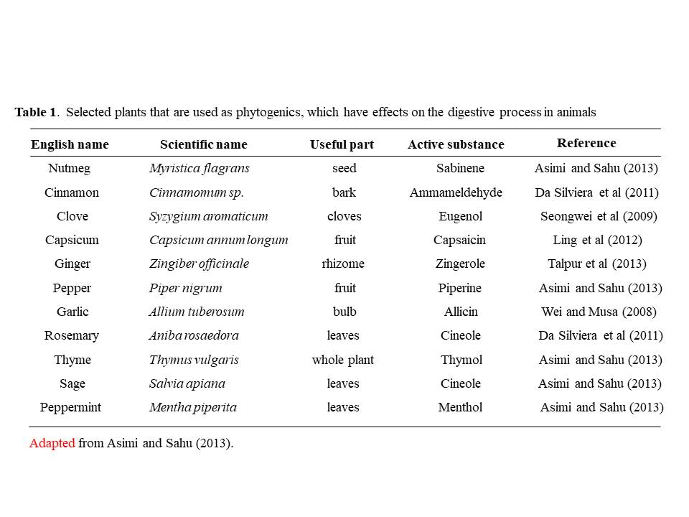
Adapted from Asimi and Sahu (2013).
Table 2. Dietary inclusion of phytogenics and its effects on (A) fish gut health and (B) gut
microflora.

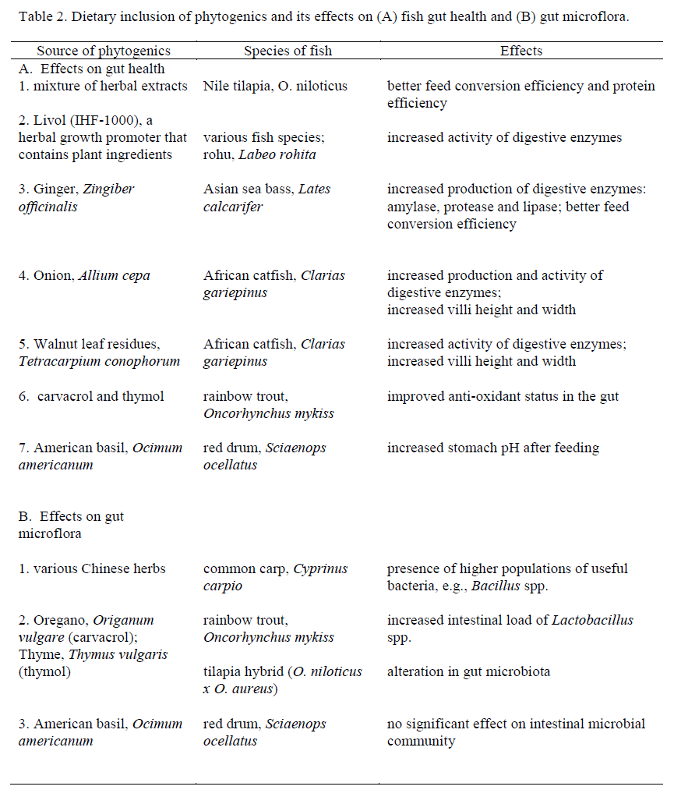

FIGURES
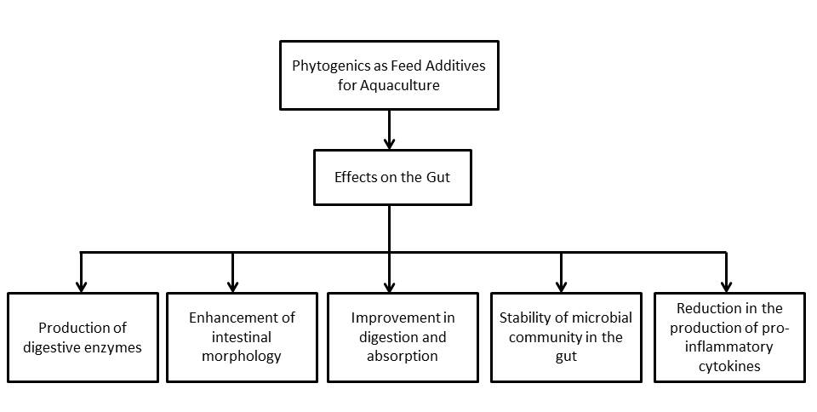
Figure 1. Possible effects of phytogenics in the gut of fish when used as feed additives.
Adapted from Steiner and Syed (2015).

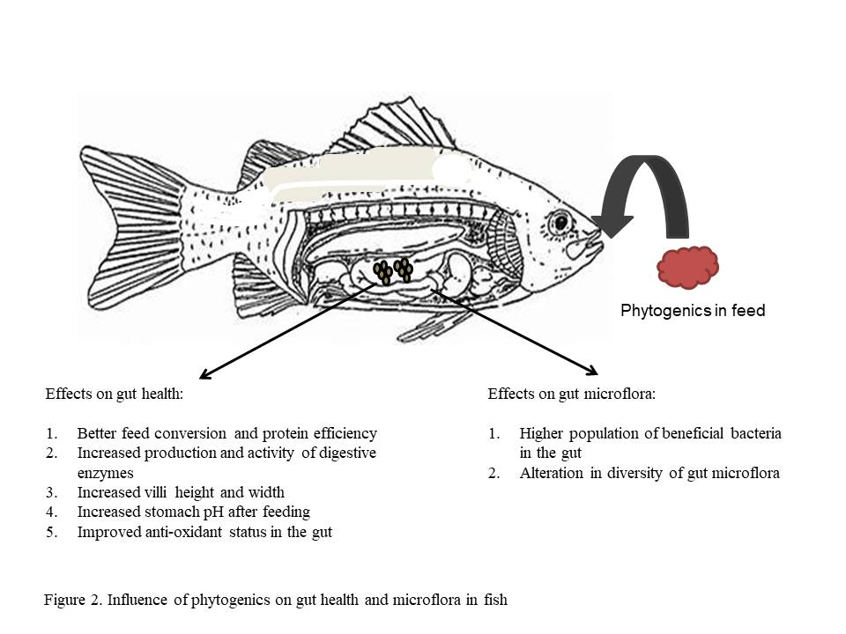

Figure 2. Influence of phytogenics on gut health and gut microflora in fish based from published studies.

